UNIT ONE: CARING FOR OUR WORLD

Lesson 4: Let’s Save Our Forests

**“The Mystery of the Missing Trees”**

***The Hillside***

"Not another one!" groaned Hisham when he finished counting trees on the hillside not far from his home. This was the third time this month a tree was missing. "At this rate," he thought, "there would be more trees on the hillside in a few years."

"I must call the TREE HOUSE Detectives for a meeting," he said himself. "We must find out why those trees are disappearing."

As he walked back, he kept his eyes peeled for clues. He had gone far when his sharp, trained eyes spotted a nut lying on ground. He picked it up and examined it closely. Part of it was worn out, but the inside was still shiny!

"It has not been around for long," he thought to himself. "I will show it to the rest of the group at the meeting."

***The Tree House***

"So what do you make of it, Hisham?" Jana said giving the nut back to him.

"I have no idea and I don't know if it will lead us to finding out why those trees are disappearing," Hisham said.

"Maybe a woodcutter is chopping down the trees for firewood," suggested Omar. "That's why it's only a few trees every month."

"Couldn't be or there would be stumps where the trees were. No, sir. Those trees just disappeared into thin air," Hisham replied. "We must find out what's happening to those trees. Tonight, each one of us will take turns watching the hillside for any strange going-ons. The one on watch will wake the rest if anything unusual happens."

***The Stakeout***

For three nights the TREE HOUSE Detectives kept watch but saw nothing. They were getting tired and bored. On the fourth night Jana was almost falling asleep when she saw weird colored lights dancing above the hillside. At first, she thought she was seeing things. She was

wide-awake now and the lights were still there. She woke up the boys and they all looked excitedly at the strange lights.

"What could they be?" Jana asked. "Do you think they could be aliens?"

"Let's go find out!" Hisham exclaimed.

"What if it's not safe?" Omar said worriedly.

"We must find out what's happening to the trees. If we don't, then there will be no more trees on that hillside," Hisham said. "Would you like to stay here or go with Jana and I?"

"I'll go," said Omar.

***Mystery Solved***

"We have to approach with care," Hisham whispered. "We don't want to make any noise and tip off whoever is there."

As they got closer, they heard a deep humming sound like a washing machine on a wash cycle. An eerie glow came from among the trees, and they heard what sounded like people speaking. Suddenly...

"Who goes there?" someone shouted.

Hisham, Jana and Omar froze in their spots. A searchlight picked them out.

"What are you doing with our trees?" Hisham shouted boldly even though he was scared.

A tall thin figure walked towards them. He looked somewhat different from people, but the TREE HOUSE Detectives thought the lights were playing tricks on them.

"I am Orion senior. I come from the planet Oricon. We are here to help save Earth's trees," the figure said.

"You're not telling the truth!" Hisham shouted. "Our trees are disappearing and you're taking them!"

"You're right, the trees seem to be disappearing, but we are not taking them. They are simply invisible," said Orion senior. "We have sprayed them with a special medicine to protect them. They will reappear soon. We were not smart enough to help the trees on our planet and now there are very few left. We want to help."

"What? They are invisible? A special medicine?" Hisham said in confusion.

"Let's see if we can feel the tree," suggested Omar.

The TREE HOUSE Detectives held their hands out in front of them

and walked in the direction of a missing tree. THUD! Sure enough the

tree was there.

"How long will the trees be invisible?" asked Jana.

"It will take a couple of weeks by Earth's time. The trees should be healthy by then," explained Orion senior. "We only do a few at a time so that no one misses them. No one except clever tree detectives, that is! Perhaps if we had had detectives like you, our trees would have been saved."

"You can help us with your science and medicine, but only people can stop cutting trees," said Hisham.

The young detectives thanked Orion senior and promised to do all they could to stop tree cutting. The next day they put up a new sign on their tree house: "THE TREE PROTECTORS".

Name: ______________________________ Date: ___________________

1. **Use the words in the box to complete the passage.**

groan eerie detective invisible mystery clues alien examined

The ____________________ was going to solve the ____________________. He began to search for ____________________ everywhere. Each one he found, he __________________

carefully. There were very strange footprints. They did not look like an animal's footprints. They did not look like a person's footprints. They looked more like the footprints of an _____________. Suddenly, he heard an _________________ sound. It sounded like a_________________. He searched, but he could not see anything. Perhaps the sound came from something ________________.

1. **Now read the following sentences and use the correct expression from the box.**

* At this rate
* disappeared into thin air
* kept his eyes peeled
* make of it.

The detective did not know what the strange sound was. He did not know

what to ____________________.

He was very alert and he ____________________ for any clues.

Suddenly, the spaceship became invisible and ____________________ the detective knew that he would solve the mystery soon.

Name: ______________________________ Date: ___________________

**A. Read the following pairs of words. If they are synonyms (almost the same meaning) write the letter on the line below to solve the message. Use a dictionary or a thesaurus if you feel you need help.**

disappear - vanish (W) strange - Unusual (D)

noisy – loud (E) little – huge (U)

finish – begin (T) happy – glad (0)

look for – search (L) shouted – yelled (N)

few – many (R) brave – bold (E)

sleepy – drowsy (L) easy – difficult (S)

___ ___ ___ ___

___ ___ ___ ___

**B. Now it's your turn. Find three sets of synonyms. Write the words on the lines below and use them in sentences.**

**_____________________________________________________________________________________________________________________________________________________________________________________________________________________________________________**

**_____________________________________________________________________________________________________________________________________________________________________________________________________________________________________________**

**_____________________________________________________________________________________________________________________________________________________________________________________________________________________________________________**

Name: ______________________________ Date: ___________________

**Help Maher get to the tree house for a meeting by following the compound words.**

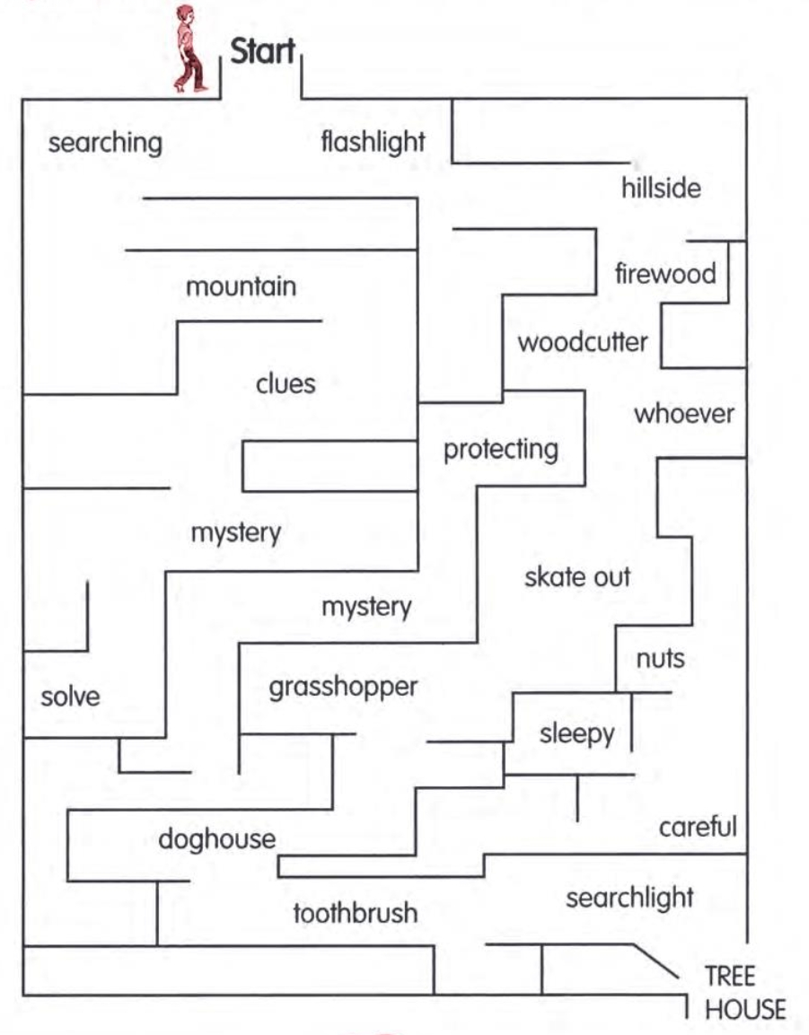

Name: ______________________________ Date: ___________________

**A. Look at the following sentences. Underline the helping verb once and the main verb twice.**

1. The trees are growing tall.

2. They are called cedar trees.

3. The Phoenicians have made many ships.

4. Trees are used for many things.

5. Trees are not growing like they did before.

6. Many people are worried about the trees.

7. The number of trees is decreasing.

8. I am planting a cedar tree to keep my country green.

**B. Now it's your turn. Write five sentences that tell what you and your classmates are doing to keep your country green.**

**_____________________________________________________________________________________________________________________________________________________________________________________________________________________________________________**

**_____________________________________________________________________________________________________________________________________________________________________________________________________________________________________________**

**_____________________________________________________________________________________________________________________________________________________________________________________________________________________________________________**